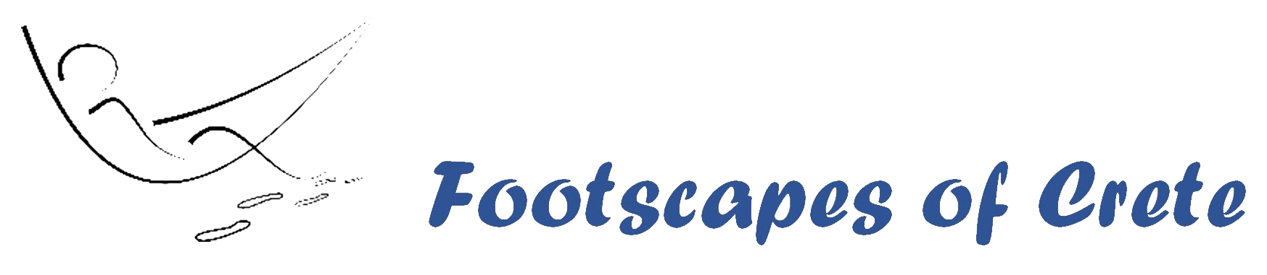

Terms and conditions holiday homes Footscapes of Crete, Crete, Greece. 15-05-‘22

General
These general reservation and rental conditions form part of the agreement between you (hereinafter referred to as the tenant) and us (hereinafter referred to as the landlord).
When booking, the tenant agrees to the conditions set out below.
* The subjects Booking, Payment, Reservation, Cancellation and Including may differ if the booking is made through another platform, other than our own booking site.
The conditions of these subjects belonging to that platform then apply.

Booking
Tenant can make a reservation by email or phone, this reservation is confirmed by the landlord by e-mail with a pro forma account as an attachment.
Upon receipt of this confirmation, the tenant must transfer a deposit of 20% of the total rent to the landlord within one week of the date of the confirmation. Than the reservation is binding. If the deposit term is exceeded, the landlord reserves the right to consider the reservation as dissolved and to release the house again for letting.
The confirmation and these conditions together form the rental agreement. The minimum rental period is 4 days A week before arrival, we send you a route description and inform you about additional service options. You inform us about your flight details.

Payment
Remaining payment of the total rent, must be transferred 56 days (8 weeks) before arrival to the landlord's account.
If the payment term is exceeded, the landlord has the right to terminate the rental agreement after which no refund of the deposit will take place.

Including
The rental price includes electricity and water.
Bed- bath and household linen.
Cleaning costs.
Wifi

Exclusive
Airco
Beach towels

Cancellation Policy
Cancellation by tenant must be notified in writing by email to landlord. The tenant pays at reservation a deposit of 20% of the full amount. The reservation is final upon receipt of payment
In case of cancellation more than 4 months before the arrival date there are no costs involved, you will receive your deposit back.
If you cancel between 2 and 4 months before the arrival date, you only pay the entire deposit.
If you cancel between 1 and 2 months before the arrival date, you pay 50% of the total amount
If you cancel within 1 month before the arrival date, you pay 100% of the total amount. A pandemic such as Covid 19 is no reason for cancellation from 2021 with a refund of the amount already paid by the tenant. The landlord cannot be held responsible for any disruption and / or change of the guest's stay, if this is the result of unforeseen or insurmountable events beyond the control of the landlord. We advice you to have a cancellation insurance.

General
Of course we cooperate if you have to cancel due to personal circumstances and want to use a cancellation insurance policy.
Departure earlier than planned - regardless of cause or cause - does not lead to a refund of paid rent.
If, due to unforeseen circumstances, the landlord is forced to cancel the reservation made, the tenant will be notified of this in writing. The amount already paid by the tenant will be refunded. The tenant has no more or other right than to the amount already paid.

Arrival and departure
We have no fixed changeover day.
The rented property is available from 3 pm, as stated in your pro forma note, on the day on which the rental period starts and must be vacated before 11 am on the last day of the rental period. Unless otherwise agreed.
Goods that are found after your departure, we keep a reasonable period for you, but we take no responsibility for this. We only send it to you at your expense.

Liability tenant
We do not use a deposit, but expect our tenants to act as a good guest and use the house with equipment with due care. The tenant must inhabit the house, the plot, and use the exterior in a good and tidy manner.
The tenant is jointly and severally liable for all damage or loss to the holiday home, parcel, inventory and / or furniture that were created during the rental period by him or his co-tenant (s).
If, despite caution, the tenant has caused damage, it is important to inform the lessor of this as soon as possible.
Depending on the damage, the reason for this and depending on what is broken, a solution will be sought in good consultation. Initially, this will be repaired at the tenant's expense by means of any travel insurance and / or statutory liability insurance. The lessee must therefore take care of appropriate liability insurance. If this is not possible, you will have to pay the damage caused by you personally.

Price handling
The published price is based on prices, exchange rates, tax levies, and taxes, as know at the time of publication. We reserve the right, even by already concluded agreements, to increase the rental price up to 21 days before your stay due to an increase in the above named prices. Of course with justification for reasons.

Miscellaneous
• It is not allowed to have more people in the home stay than what has been agreed.
• Obviously, there should be no disruption occur for local residents.
• Smoking in the house is not allowed.
• Bringing pets is not allowed.
• The landlord is entitled to enter the holiday home during your stay for maintenance and cleaning work and for safety reasons.

Non-compliance with general conditions, disclaimers and house rules.
If the tenant and / or co-tenants do not or not properly comply with the obligations from the general conditions / house rules or disclaimers, despite possible prior warning, the landlord has the right to terminate the agreement with immediate effect and deny the tenant and co-tenants access to the holiday home without refund of rent.

